Friction Mini-Assessment
TOTAL:39 _________
1. State three everyday activities you couldn’t do without friction.

___________________________________________________________________________________

___________________________________________________________________________________
(3 marks)

2. List three ways to reduce friction.

- ______________________________________________________________________

- ______________________________________________________________________

- ______________________________________________________________________
(3 marks)

3. State whether the following are true or false.

- Friction acts in the same direction as an object’s motion.
_________________

- The greater the weight of the sliding object, the less the force of friction it experiences.
_________________

- Friction makes a machine more efficient.
_________________

- Streamlining reduces friction.
_________________ (4 marks)

4. Without friction, you could not pick up a basketball. Explain why.

_____________________________________________________________________________________

_____________________________________________________________________________________

_____________________________________________________________________________________
(2 marks)
5. A mountain bike is designed to be considerably heavier than a road bike.
Explain why this is the case, considering the typical surface each is used on.
_____________________________________________________________________________________

_____________________________________________________________________________________

_____________________________________________________________________________________
(2 marks)

6. Calculate the average friction force measured when moving each block.

Object Moving | Friction Force Measured |  |  | Average
Object Moving | Trial 1 | Trial 2 | Trial 3 | Average
Block | 12 | 13 | 11
Block + 100g | 14 | 15 | 15
Block + 200g | 16 | 17 | 17
Block + 300g | 19 | 18 | 19
Block + 400g | 21 | 21 | 20
(5 marks)

7. Classify each of these as increasing or decreasing friction.

a. Increasing the weight of an object. ________________________________

b. Making a surface rougher. _______________________________

c. Streamlining an object. _____________________________

d. Using oil in an engine. _______________________________

e. Adding small bumps on a basketball surface. _______________________

f. Using ball bearings in a wheel. ______________________

- Polishing the bottom of skis. _____________________
(7 marks)

8. Compare the level of friction present between a new pair of running shoes and a very old worn pair of running shoes.

_____________________________________________________________________________________

_____________________________________________________________________________________

_____________________________________________________________________________________
(2 marks)

9. Explain why this is the case.

_____________________________________________________________________________________

_____________________________________________________________________________________

_____________________________________________________________________________________
(2 marks)

10. The minivan below is travelling along a flat road. Use the picture to answer the following questions.
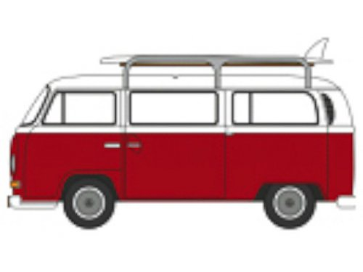

- Name two sources of friction that are acting on the minivan.

_______________________________________________________________________________
(2 marks)

- State the direction in which these forces act.

______________________________________________________________________________
(2 marks)

- The surfboard is now removed from the roof-rack.

i) State whether the friction acting on the car would increase or decrease.

_______________________________________________________________________________

_______________________________________________________________________________

_______________________________________________________________________________
(1 marks)

ii) Justify your answer.

_______________________________________________________________________________

_______________________________________________________________________________

_______________________________________________________________________________
(2 marks)

11. Weightlifters rub chalk into their hands before attempting a lift. The chalk absorbs any sweat on the weightlifter’s palms.

Propose why weightlifters use this chalk.

_____________________________________________________________________________________

_____________________________________________________________________________________

_____________________________________________________________________________________
(2 marks)

